Project Title: ON BORDING

Project Manager: Arun Kumar B, Mukesh Kumar

Project Member:- Shubham Rai, Kamlesh Kumar and Kalla Prasanna

Users: Tricon Infotech Employee

Purpose of the project:

The purpose of the project is to automate the on boarding system for the new employees and to allow older employee to view their details. This will help in onboarding process during hiring of the new employees. Previously it was done via pen and paper and it was very tedious process to write lot of details, this functionality also reduce the chance of error and makes form - filling task quit easy. The whole purpose is of this project is to make employee data base and connect with the pay wheel (a product from tricon itself).

Work Done Till 16th Of August:

* Discussion on which technology will be used.
* Finalized Technology : Front-End – React, Backend- Java, Spring Boot , Database – MySql.
* Architecture Design : A demo of full architecture what is the flow of the project, that includes table structure of database.

**Architecture Design:**

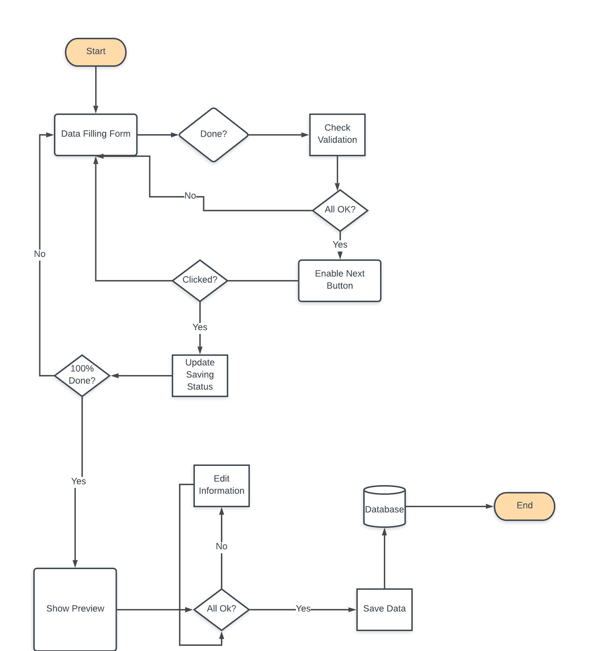

A demo of full architecture what is the flow of the project:

As you can see, the flow of the diagram shows the overall architecture of the project, we are going to work on frontend and backend simultaneously and update for the same.